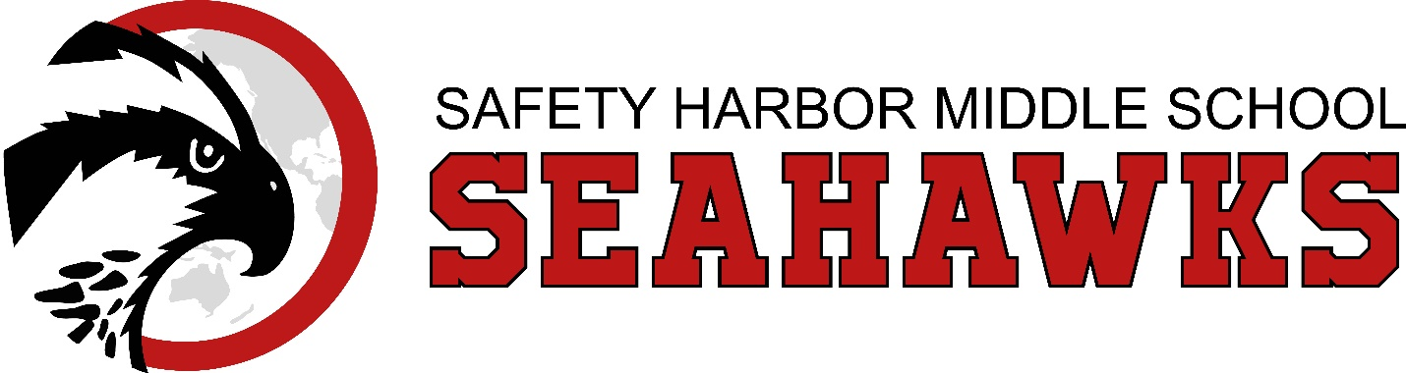
Mission:
Safety Harbor Middle School empowers our teaching and learning community to form compassionate and respectful relationships and cultivates collaborative, inquiry-based learning that supports our students’ college and/or career preparation in a highly interconnected world.
Safety Harbor Middle School
SAC Minutes September 18, 2023
Attendants: Sara Rosado, Jing McPherson, Krystel Justice, Dan Howell,
Kristen Penna, Eve Gregg, Danny Boulieris, Toni Powers

- Principal’s Welcome & Introductions
Mrs. Powers began the meeting at 5:15 pm and welcomed everyone and introductions were made. The following information was reviewed by all attendants:

- Purpose & Responsibility of School Advisory Council
The primary purpose of the SAC is to provide parents, teachers, and all members of the community and opportunity to actively participate in the development of education priorities, assessment of school needs, and implementation of the School Improvement Plan (SIP).

It is the responsibility of the School Advisory Council to help increase student success. In the process of developing the school improvement plan, the SAC conducts a needs assessment that identifies internal and external factors that affect student learning. Then, working with the information revealed by the needs analysis, the SAC assists in clarifying the vision for the school and establishing indicators of student success. The SAC focuses on the needs of students, including what they need to know (curriculum content) and be able to do (performance application). The plan also should reflect any special interests and needs of the students and community served by the school. Another primary task of the SAC is to regularly communicate with other parents, educators, students and the community about the school improvement plan. Other key responsibilities of the School Advisory Council include: • working as a team; • holding well-publicized, open meetings; • encouraging innovation; and • involving other members of the school community in the school improvement process. Each school in the State of Florida must have a SAC. While Pinellas County Schools has always encouraged parent and teacher participation in the strategic planning process at both the district and school levels, Florida law requires it. Also by law, each School Advisory Council must be composed of the principal and an “appropriately balanced” number of stakeholders. These individuals must be representative of the ethnic, racial and economic makeup of the community served by the school. The majority of SAC members (over 50 percent) must be non-district employees.

- SAC Roster & Membership
The majority of SAC members (over 50 percent) must be non-district employees
Principal, SAC Chairperson, SAC Secretary, SAC Members, Teaches, Support Staff, Parents,
Business & Community Members
Mr. Howell nominated himself for the SAC-Chairperson. Mrs. Gregg seconded it. All were in
favor.
- Review & Approve School Improvement Plan

- Upcoming SAC Meeting Dates
SAC Meeting dates are: 9/18, 10/9, 11/13, 12/11, 1/8, 2/12, 3/4, 4/8, 5/13 @ 5:15 pm

- Open Agenda
SAC is planning to hold a Parent University on October 23rd from 6 pm – 7:30 pm. Mrs. McPherson and Ms. Justice will create a Parent Survey to gather more information regarding the needs for the Parent University Parent Night. Mrs. Powers will send it out for the Friday Message.

The meeting was adjourned at 5:58 pm.

